Joe Roberts:
From Skidrow to CEO
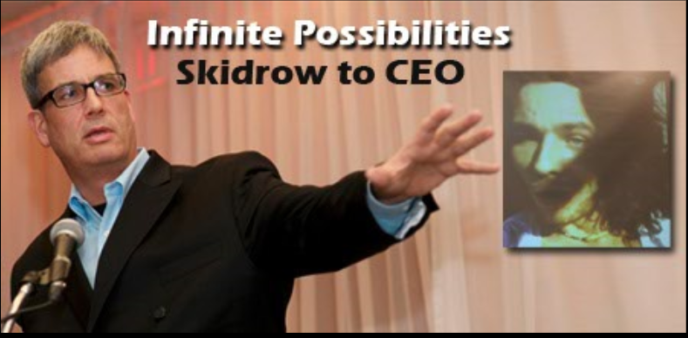

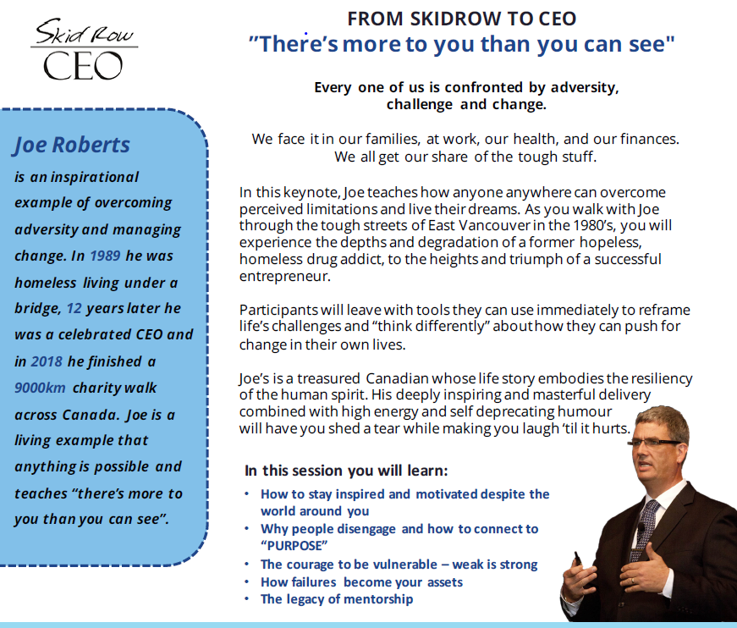
Join us for this FREE presentation that will be informative for all community members including those supporting persons with addiction & mental health needs.
Tuesday, February 19, 2019 from 4-6pm
Collingwood Collegiate Institute – in the Gym
6 Cameron Street, Collingwood
Pre-register to reserve your seat by email to:RSVP.CCIevent@scdsb.on.ca
Event sponsored by Human Services Justice Co-ordination Committee Collingwoodin partnership with Collingwood Collegiate Institute

